MONITOR UPTIME USING HEARTBEAT

1. Go to Observability > Uptime

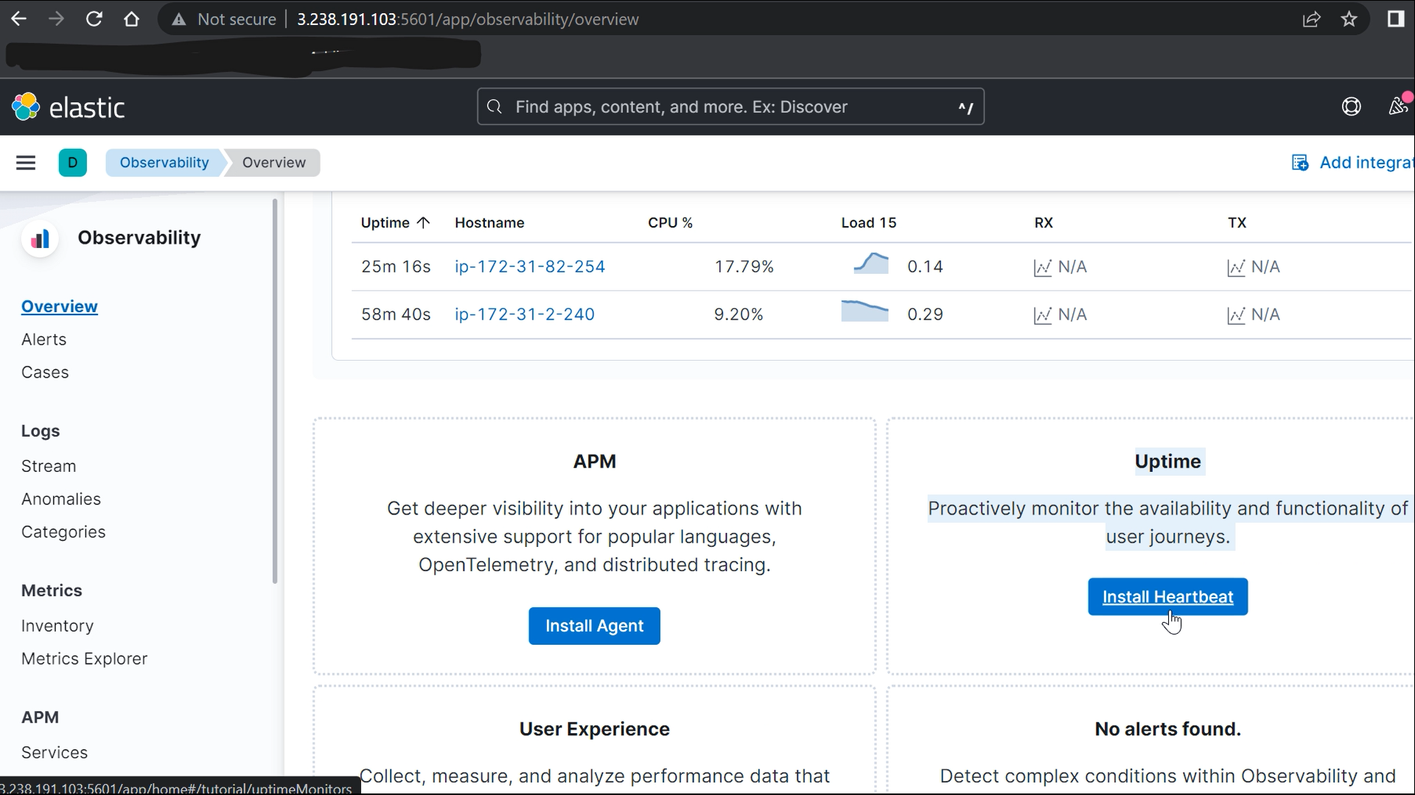

1. Make sure the elastic-agent , and an application to be monitored is running on the instance.

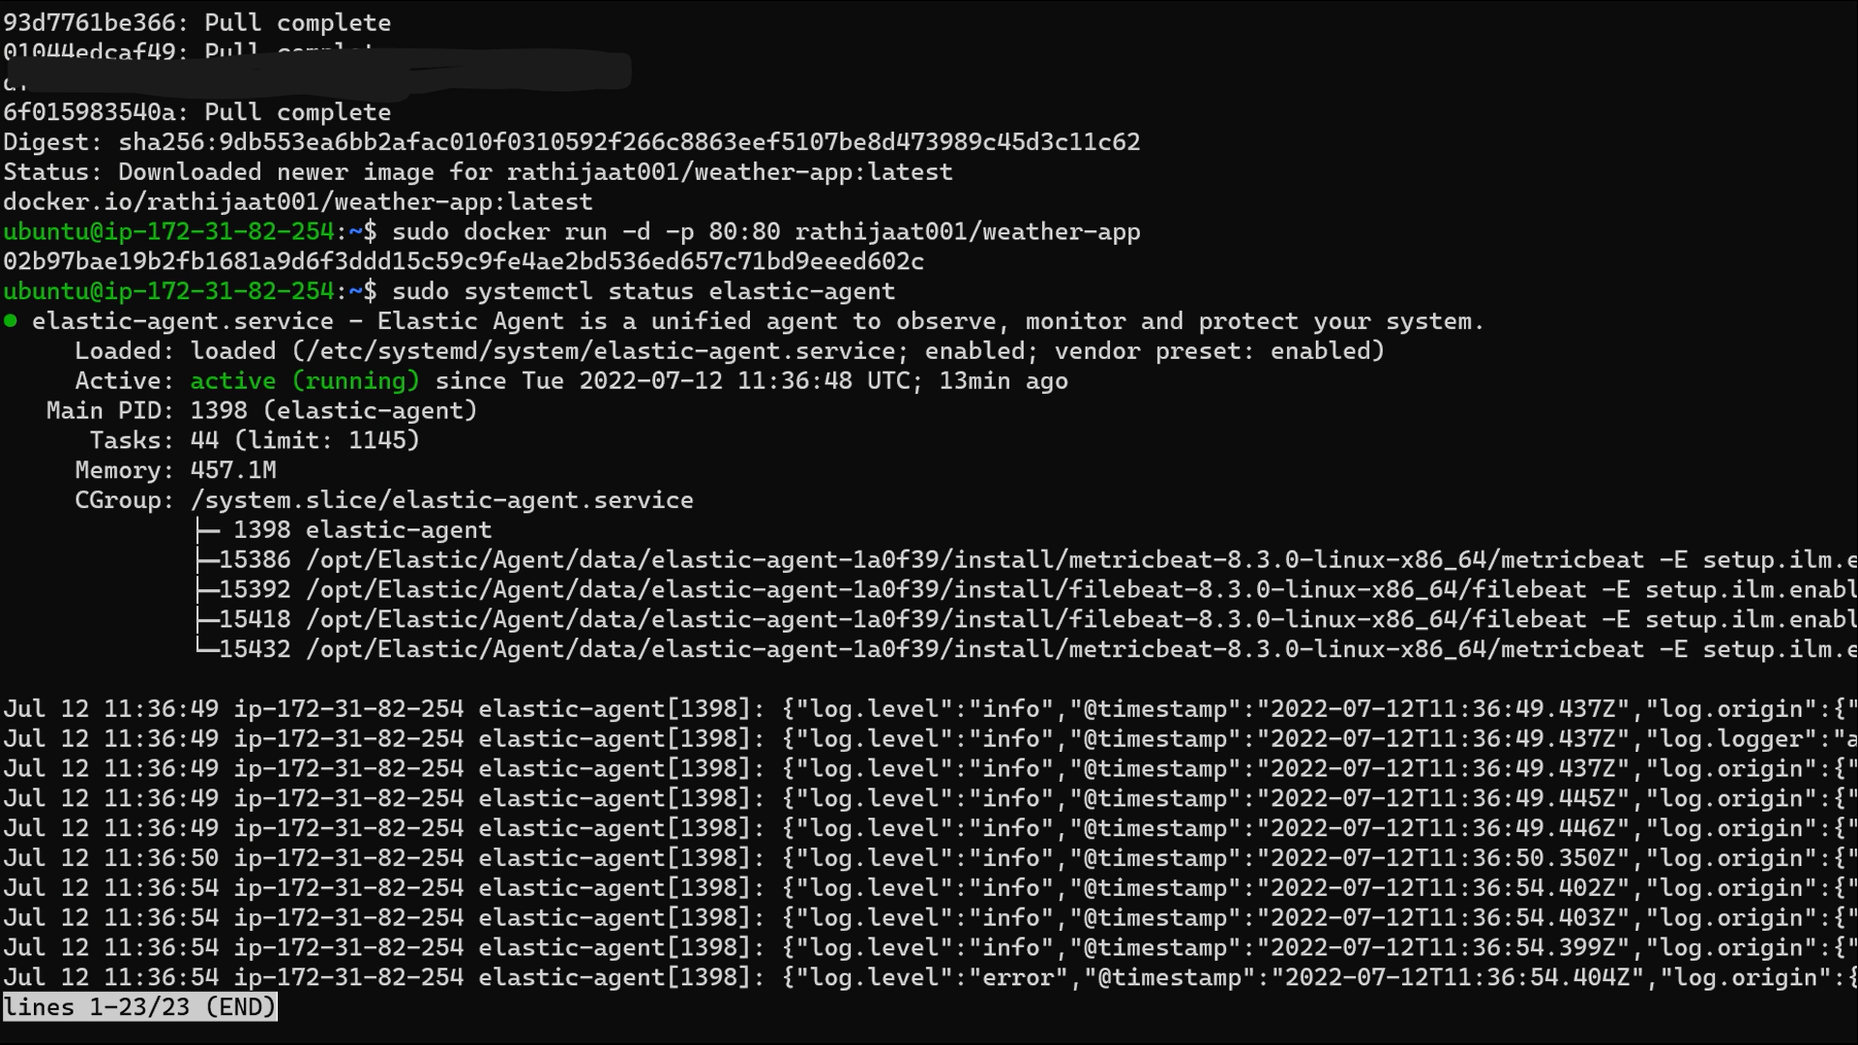

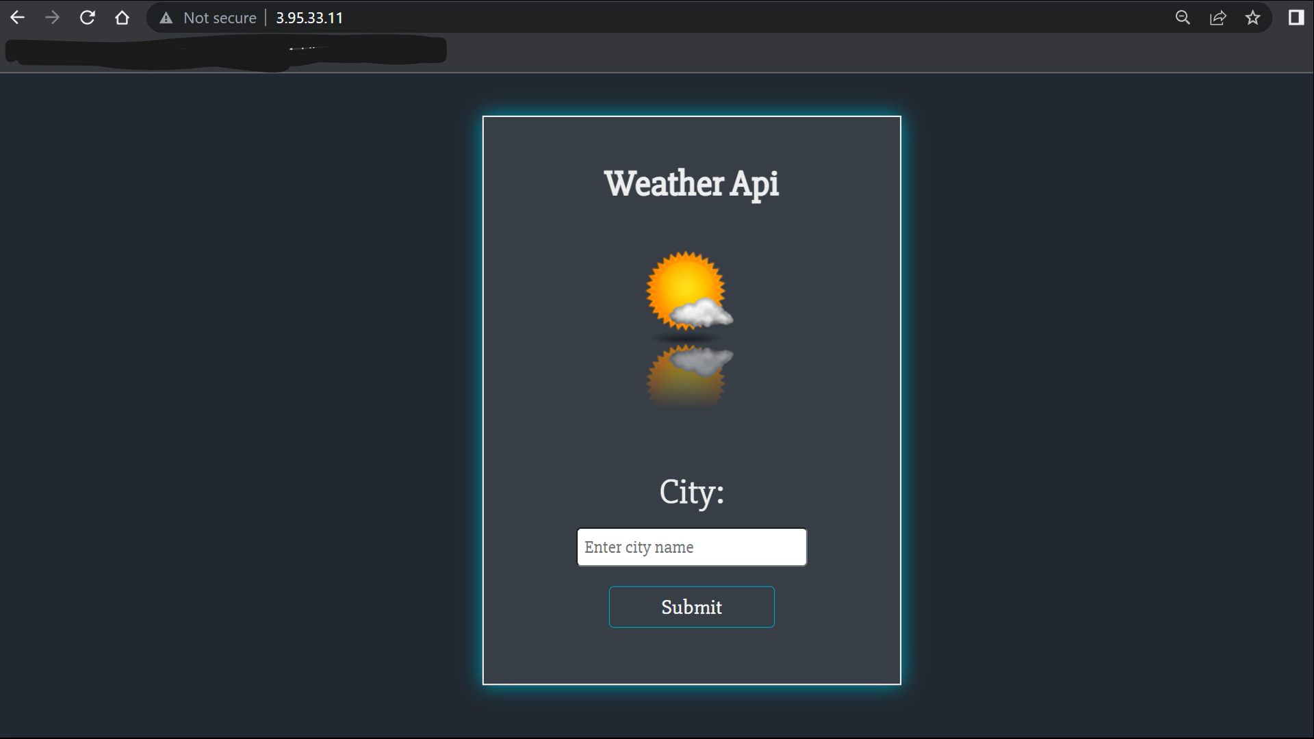

1. Click on Install uptime in the Observability > Uptime

Download and install heartbeat using the commands given.

**curl -L -O** [**https://artifacts.elastic.co/downloads/beats/heartbeat/heartbeat-8.3.0-darwin-x86_64.tar.gz**](https://artifacts.elastic.co/downloads/beats/heartbeat/heartbeat-8.3.0-darwin-x86_64.tar.gz)

**tar xzvf heartbeat-8.3.0-darwin-x86_64.tar.gz**

**cd heartbeat-8.3.0-darwin-x86_64/**

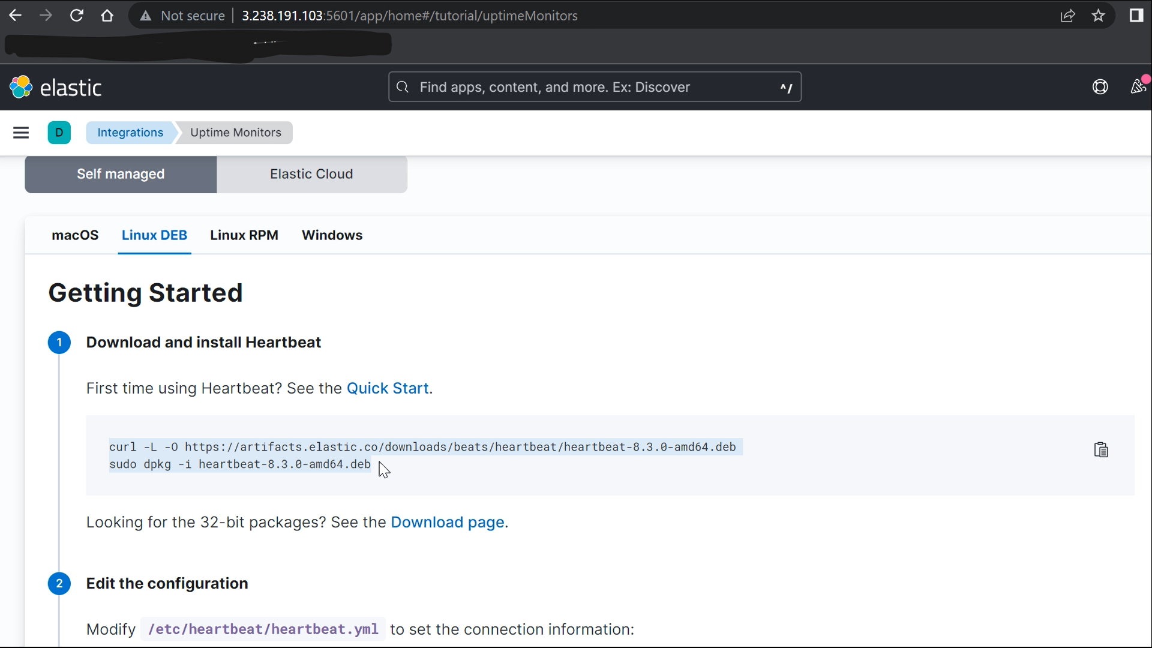

1. Now to configure the heartbeat we need to change heartbeat.yml

**sudo nano /etc/heartbeat/heartbeat.yml**

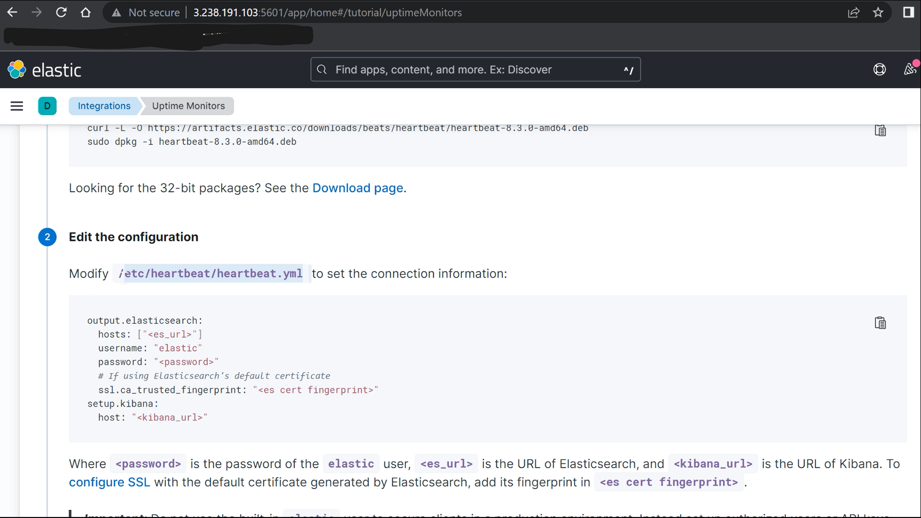

1. Change the heartbeat.monitors and provide service name to be displayed on kibana and ip , port which you want to monitor.

**NOTE: Make sure *enabled: true* in heartbeat.monitor,**

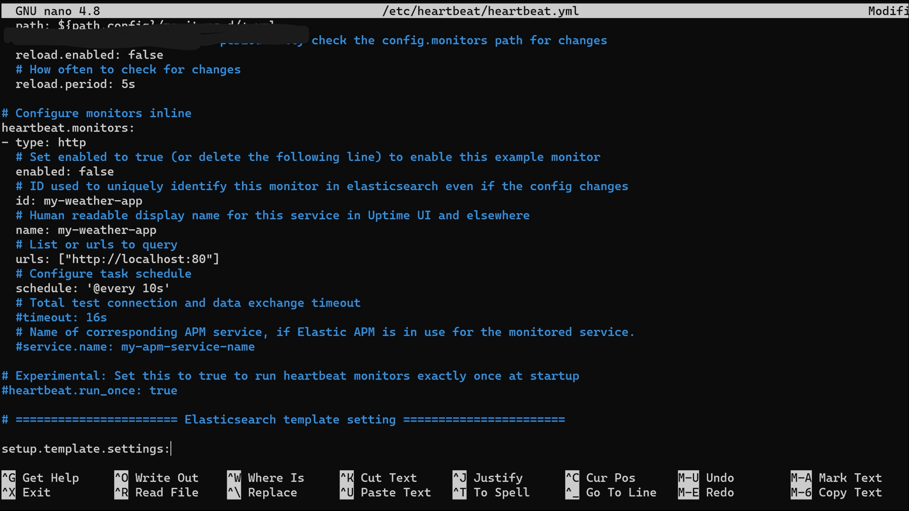

1. Now setup kibana to set up the dashboard on kibana.

Give the **private Ip** of the instance where elastic and kibana are running.

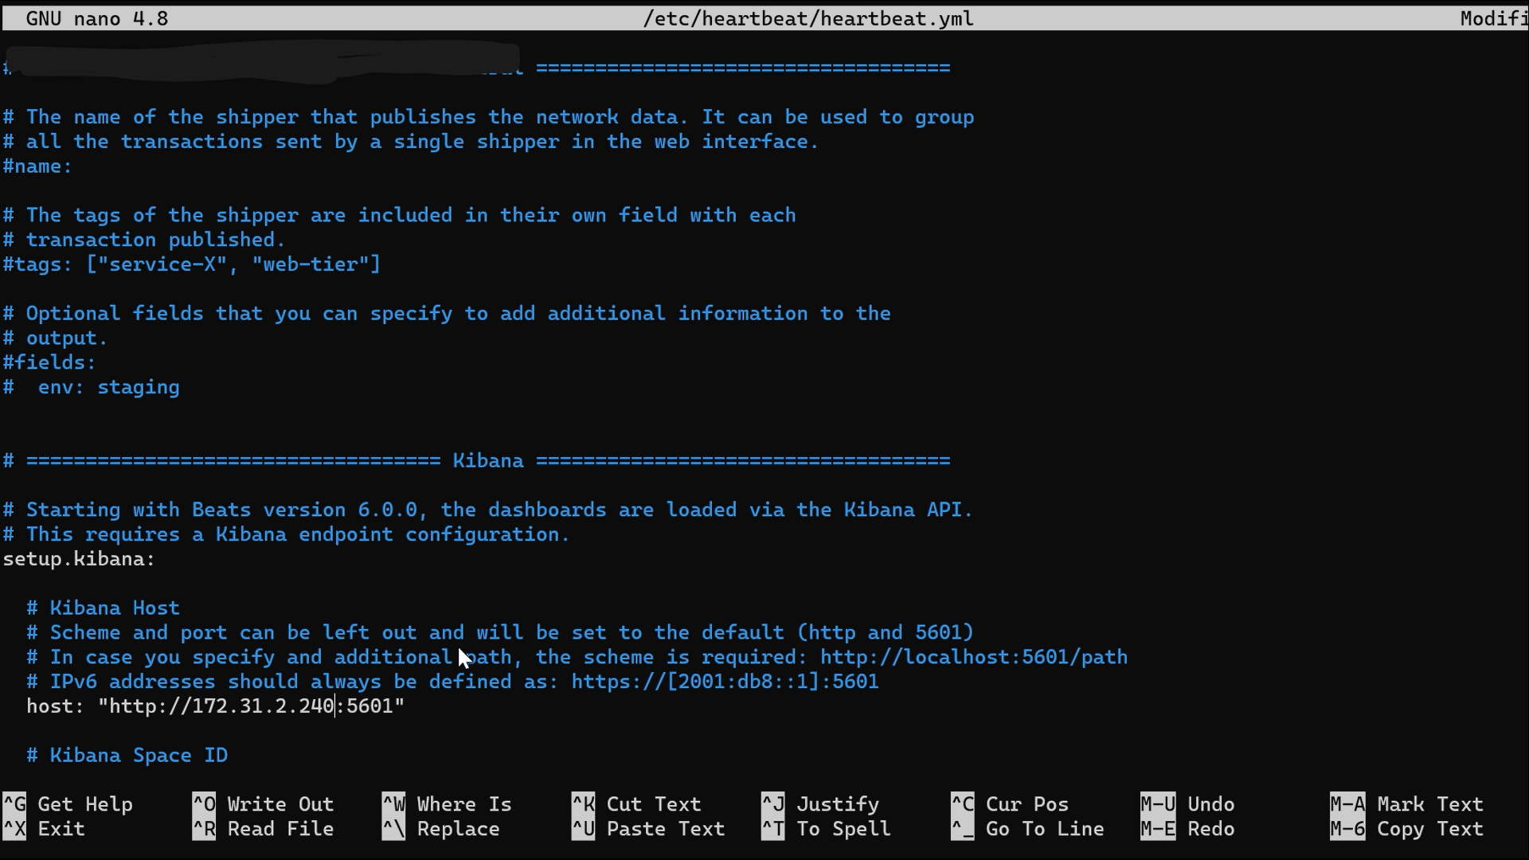

1. Now setup the elasticsearch output to enable heartbeat to add data to the elasticsearch database.

Give the Private Ip , if you are running elasticsearch with https security then give protocol as https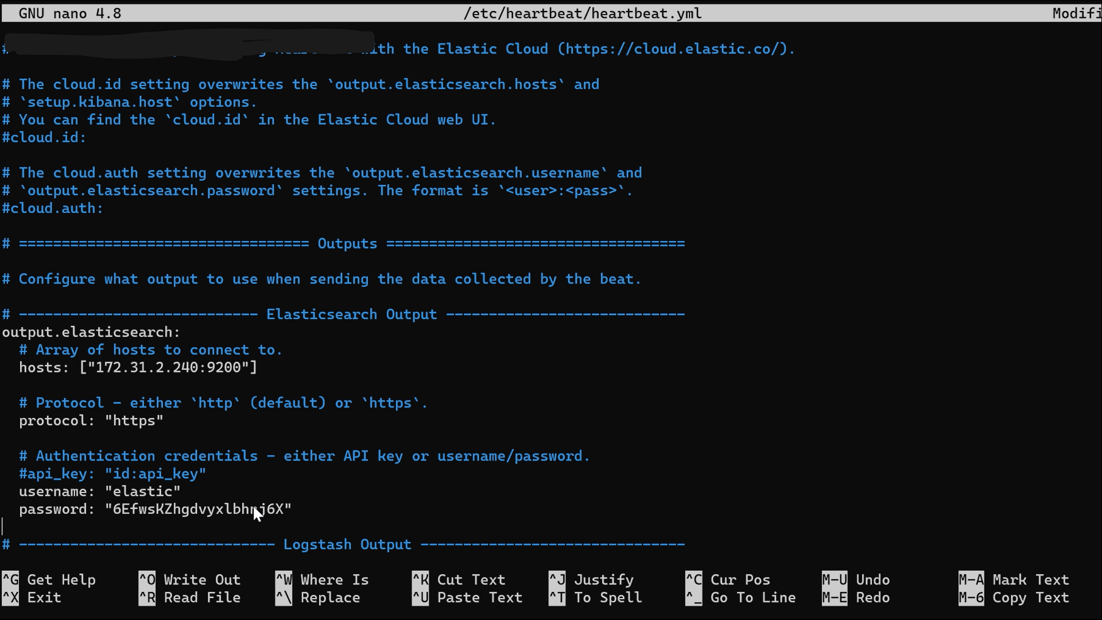

If the security is enabled then you will also need to provide Elasticsearch trusted fingerprint.

**Not Recommended**: You can also provide certificates made using cert tool of elasticsearch.

1. If you do not have the es-ca-trusted-fingerprint , then you can copy it from the fleet server.

Fleet > Add agent > Fleet Policy > add host > generate token > **Install Commands**

At the last line of ./elastic-agent install you will find *fleet-server-ca-trusted-fingerprint*, copy the value of this parameter.

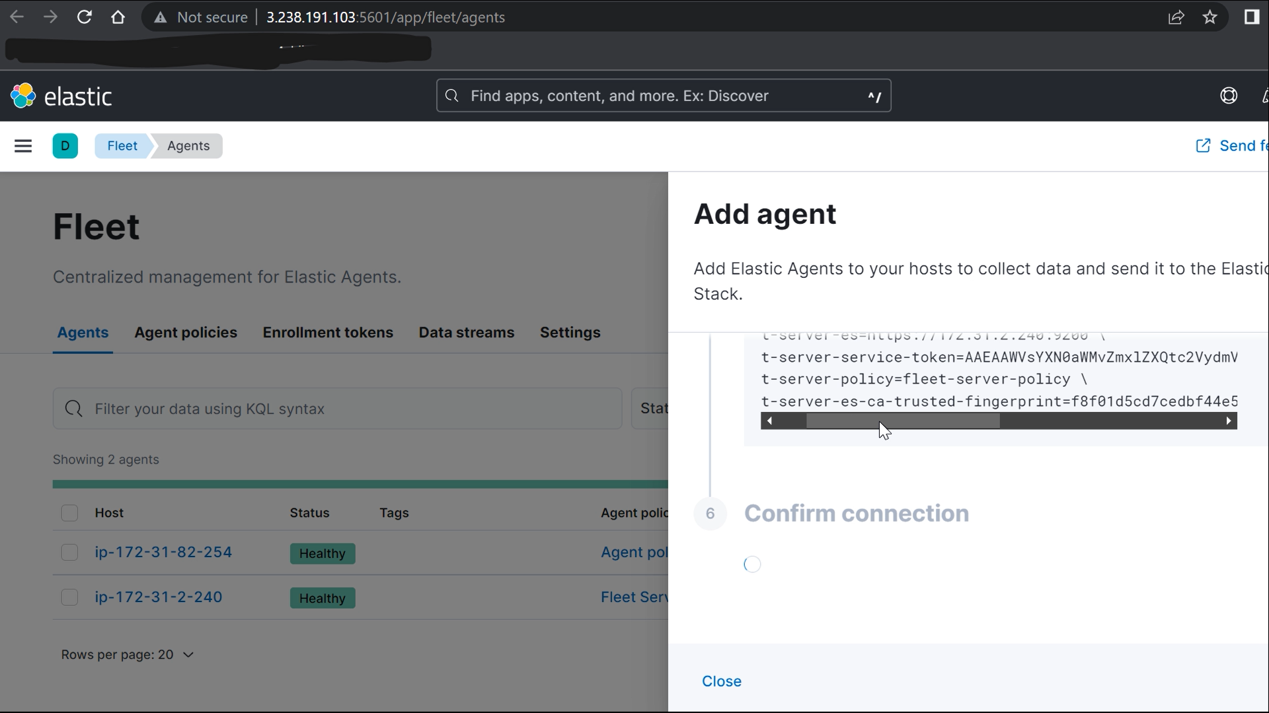

Add the fingerprint value as shown below.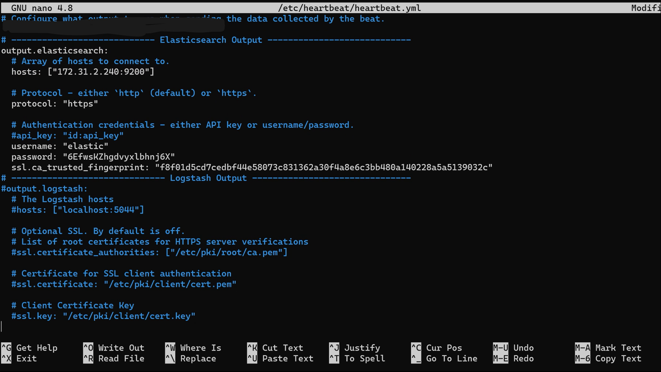

**ssl.ca_trusted_fingerprint: "<es cert fingerprint>"**

Run commands to setup

sudo heartbeat setup , or

sudo heartbeat setup -e , for logs

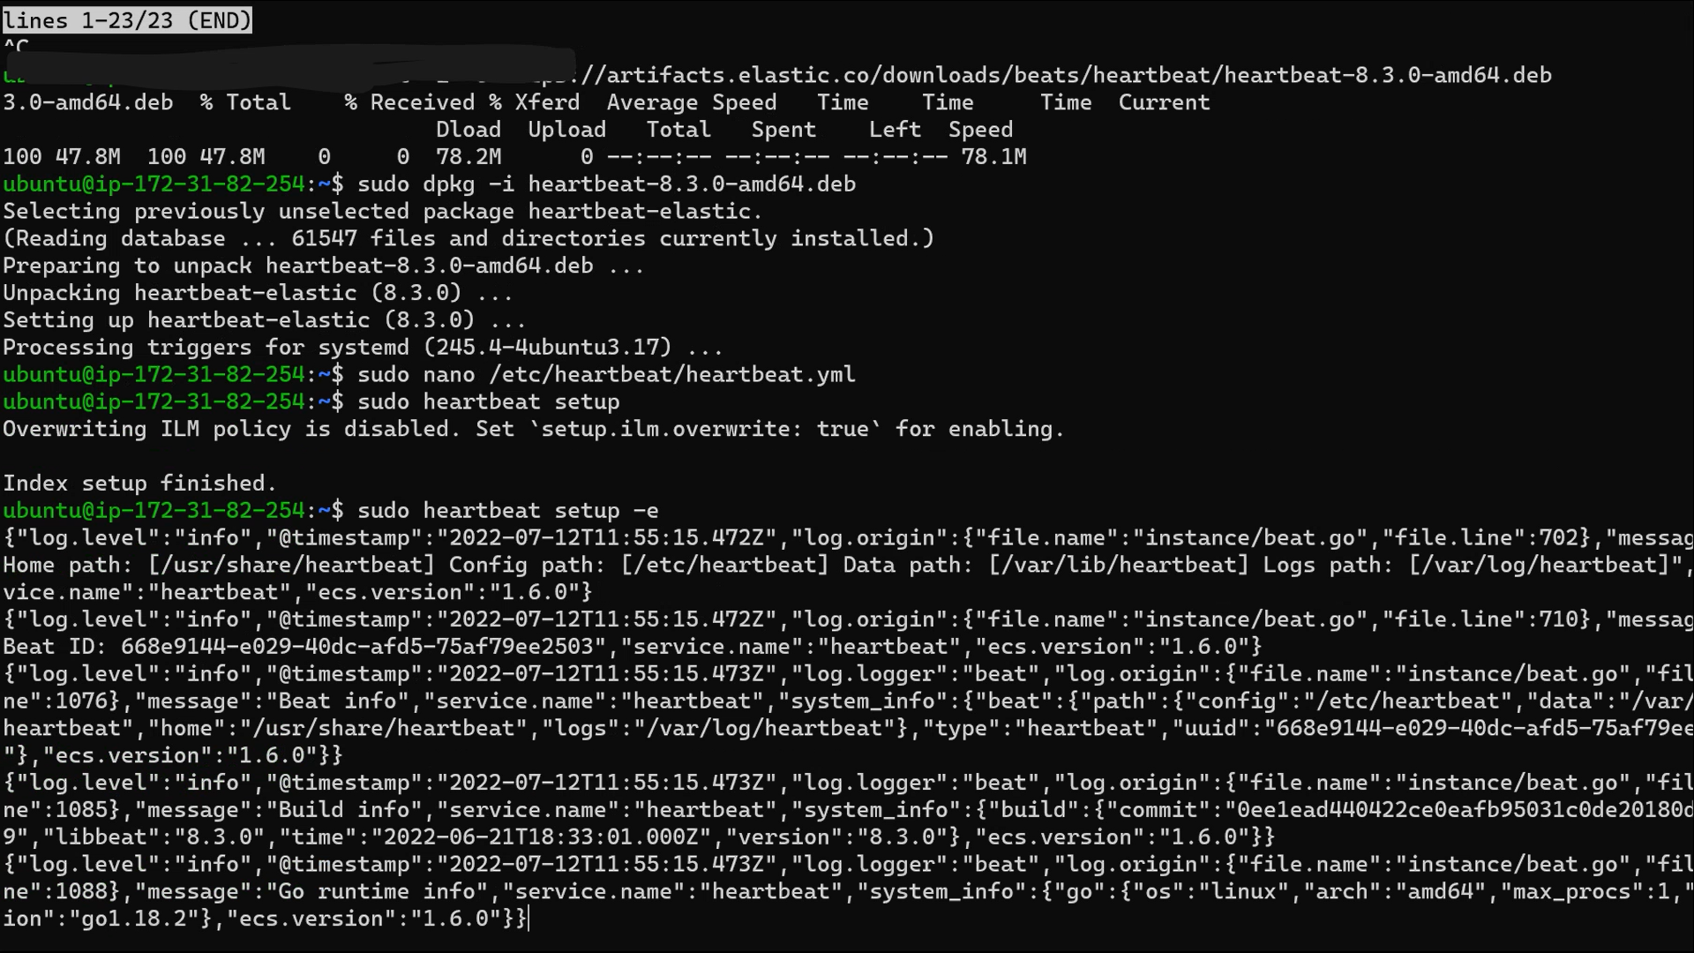

Start the heartbeat:

sudo service heartbeat-elastic start

sudo service heartbeat-elastic status

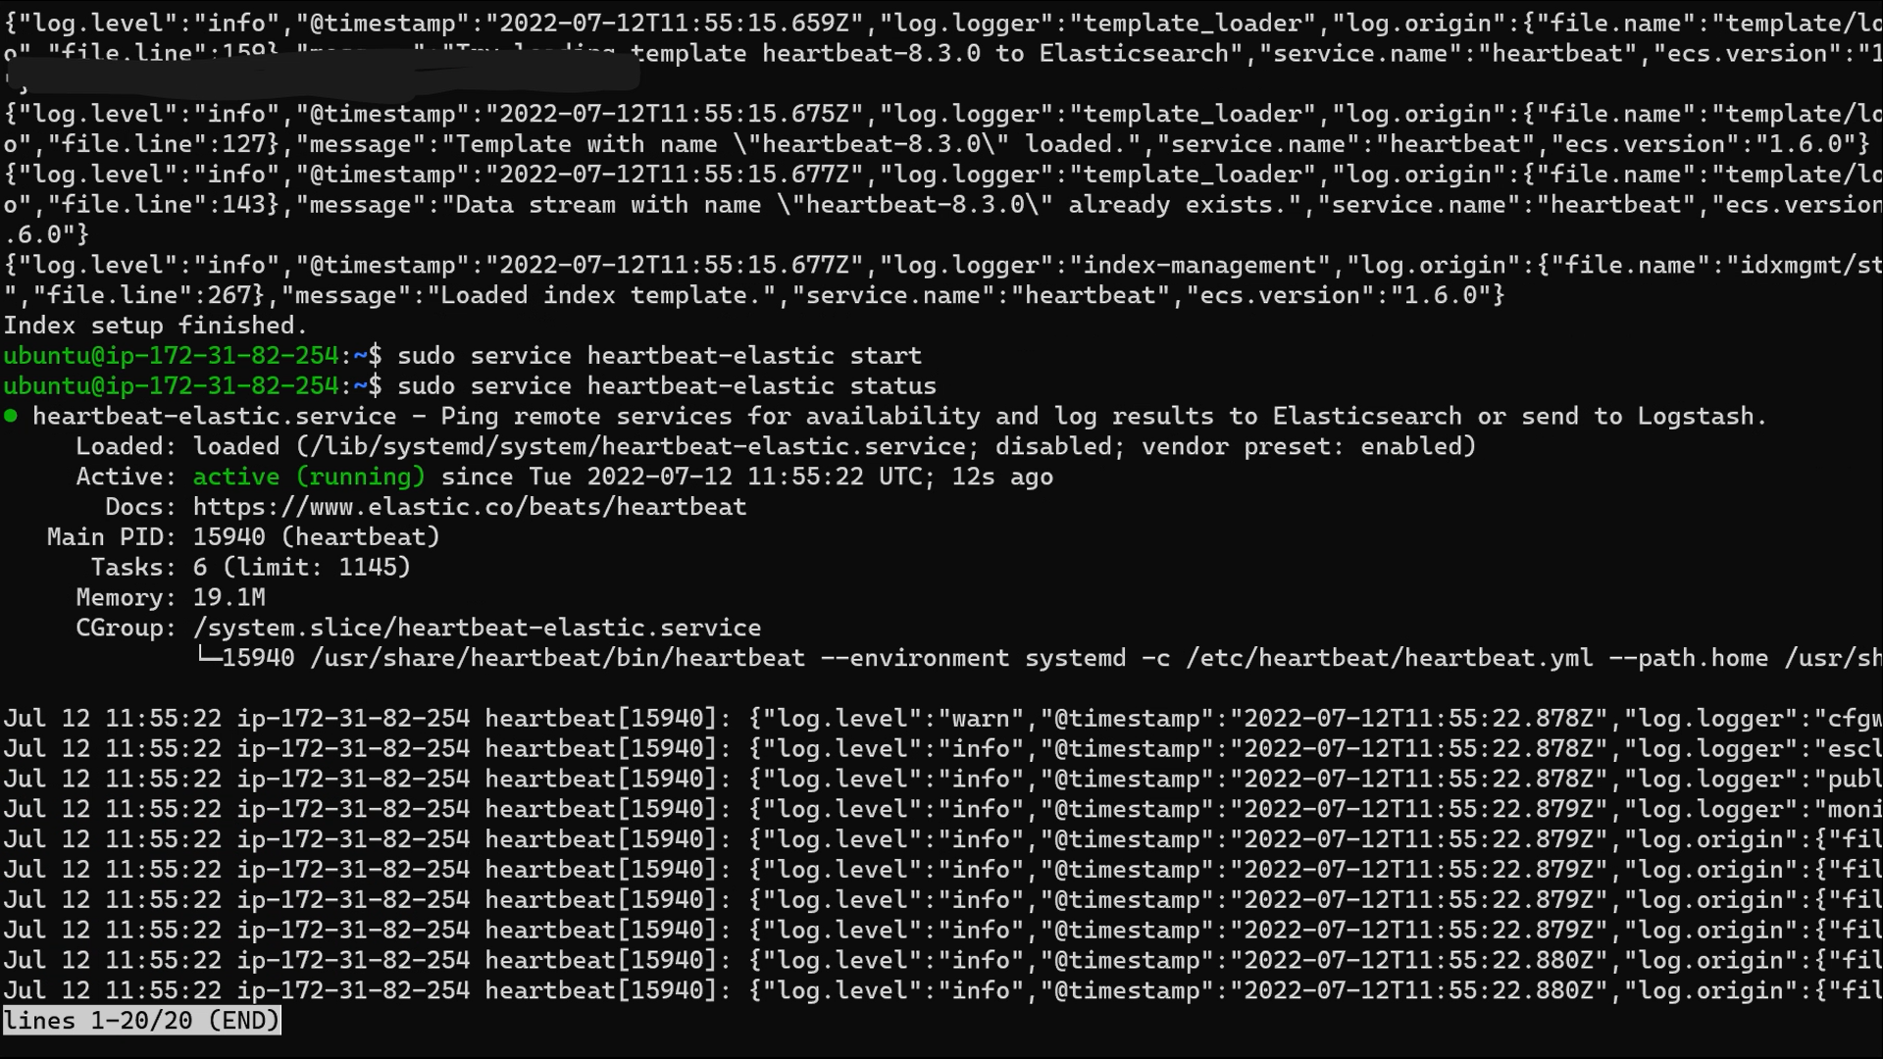

Data will be successfully received in the kibana dashboard.

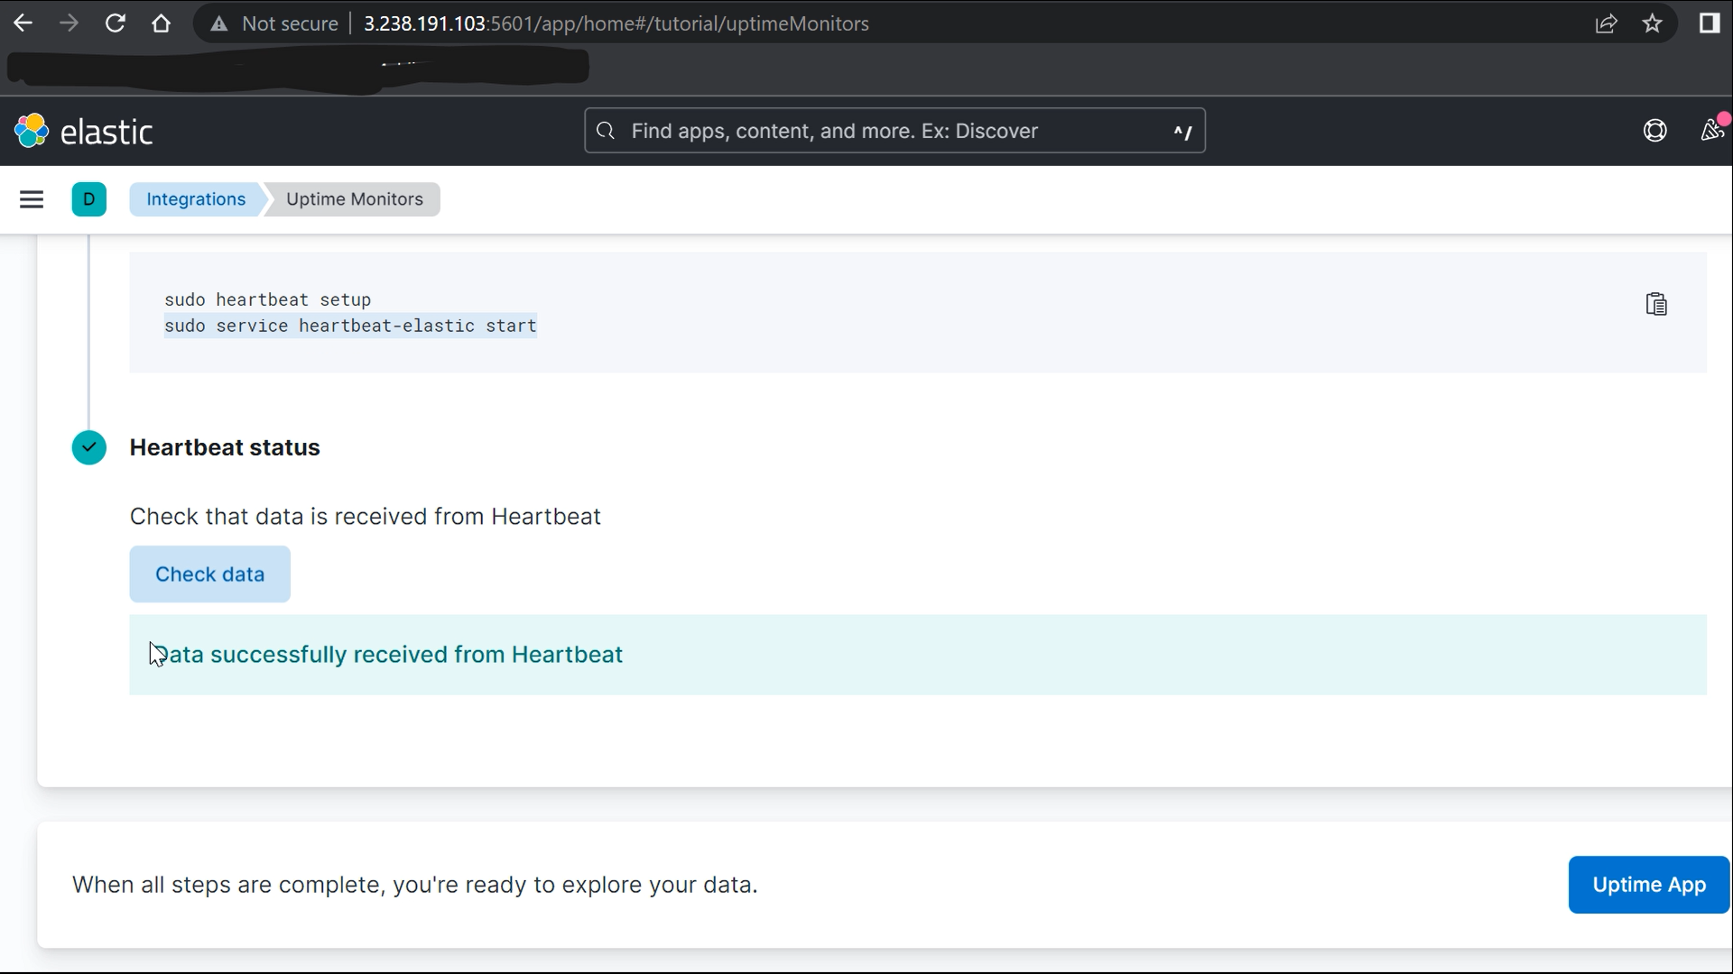

Check Uptime > Monitors

